Week 2

Objectives of this practical
- Identify suitable tools for suitable tasks and uses them effetely in the day to day office activities.
- Identify the following features in MS word,
- text and paragraph formatting
- spelling & grammar checker
- Thesaurus
- Adding comments and footnote to a document.
- Identify the various inserting objects for a word document such as tables, pictures, shapes.

- Create following news article and save in word folder

News
Latest news
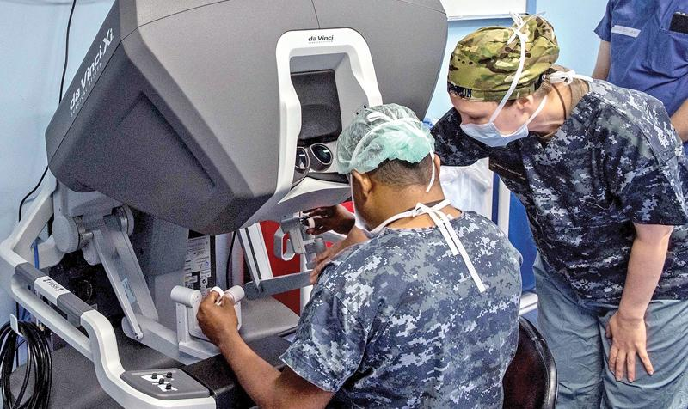

A
chieving another significant milestone in emergency preparedness and healthcare, USNS Mercy while docked in Trincomalee on its Pacific Partnership mission recorded the first robotic assisted surgery aboard a hospital ship, performing a cholecystectomy or gall bladder removal on a Sri Lankan patient.A moment of many feelings. Elation, anticipation mixed with anxiety.

- Create following passage in next page and insert comment to word corruption.

Wide powers for commission; interim report in two months
By Chandani Kirinde
Corruption, fraud, and misuse or abuse of power in the past five years are among subjects for probe by a Presidential Commission which will present an interim report in two months and a final report within a year, according to a gazette notification issued this week.
- Practices with left and right alignment.
Higher National Diploma in Information Technology
Advanced Technological Institute
Personal Computer Application
Semester 1
Practical Assignment 2

- Create following page in same document (bulleted list, Numbered list, and multilevel list) and insert background image and make it as watermark.

Number and bulleted list
Network Management

- Fault Management
- Configuration Management
- Accounting Management
- Performance Management
- Security Management

Topology
  - Bus topology
  - Star topology
  - Ring topology
  - Tree topology
- Computer Science
  - CS Part1
- Word Processing
- Multimedia
- Operating System
- Spread sheet
  - CS Part 2
    - Programming concept
    - Structured Programming
    - Visual Programming

5. Using equation command in insert tab create following equation.

Equation

6. Inset following using super script and subscript. Give footnote to H₂O₂ as Hydrogen Peroxide.

Superscript and subscript and footnote

10² CuSO_{4.}H₂ O

H₂O₂1 (C₆H₅)₃N

1 Hydrogen peroxide

